Press release ifm-pm 871/0826 Area: Flow meters

Flow measurement without intervention in the pipe
Essen, 5 October 2026 – Interrupting a reliably operating process to install a flow sensor inside a pipe? That will no longer be necessary. The new SUC300 clamp-on ultrasonic sensor from ifm enables non-invasive flow measurement without any intervention in the pipe. It also features automatic wall thickness detection, ensuring outstanding measurement performance.
Flow is one of the most important process variables in the process industry. In practice, however, companies are often faced with the challenge of integrating new sensors into existing installations. Until now, this would frequently require cutting into the pipe in order to install the sensor. The SUC300 clamp-on ultrasonic sensor from ifm significantly simplifies this process. You simply position the sensor on the pipe, attach the counterpart and tighten it in place.
Automatic wall thickness detection improves measurement accuracy
A key feature of the clamp-on sensor is its automatic wall thickness detection. During commissioning, the sensor determines the actual pipe wall thickness and incorporates this information into the flow measurement calculation. This considerably simplifies parameter setting, particularly in existing industrial facilities where pipe specifications are often not fully documented. By accounting for deviations between the nominal and actual wall thickness, the sensor further enhances measurement performance. Wall thickness has a direct impact on the ultrasonic signal path and therefore on the calculation of the flow rate.
At market launch, the sensor is available for DN40 and DN50 nominal pipe sizes, with additional variants already under development. The SUC300 is designed for measuring water-based media and can be used on pipes made of steel, stainless steel and plastic materials such as PVC. Integration is achieved via a standardised M12 connector. During commissioning, users benefit not only from the automatic wall thickness detection but also from an intelligent setup wizard that guides them through the installation process step by step. As a result, the sensor can be brought into operation within a very short time. For integration into existing infrastructures, the device offers IO-Link, an analogue output as well as pulse, switching and diagnostic outputs. Its stainless-steel housing is certified to IP67 and IP69 protection ratings, making it suitable for applications with demanding cleanliness and hygiene requirements.
Suitable for temporary applications
Thanks to its clamp-on design, the flow sensor is suitable not only for permanent installation in existing systems but also for temporary measurement tasks. Typical industrial applications include troubleshooting, verification of existing measuring points and mobile consumption analyses. As no modifications to the pipe are required, the SUC300 ultrasonic sensor can be deployed flexibly at different measurement locations. Further information about the sensor is available on the ifm website: http://ifm.com/cnt/SUC
Prize draw during SPS trade fair
ifm will be showcasing the SUC300 clamp-on ultrasonic sensor at Smart Production Solutions (SPS), taking place in Nuremberg from 24 to 26 November. During the exhibition, ifm will be running a prize draw in which ten sensors of the new flow sensor type will be given away.
ifm at SPS: Hall 7A, Stand 302
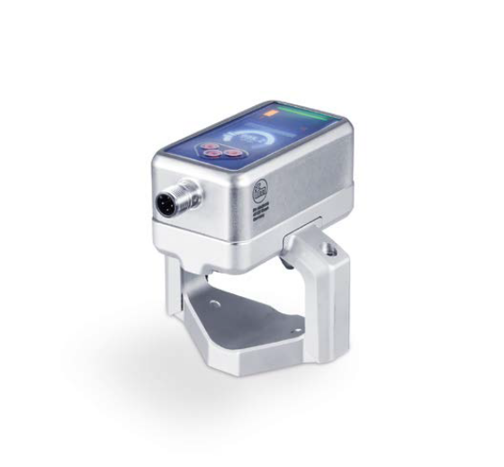 | ifm-pm 871 print.jpg  Copyright: ifm  The new SUC300 clamp-on ultrasonic sensor enables flow measurement without pipe intrusion.

About the ifm group of companies

From a passion, to an idea, to success. Since its foundation in 1969, ifm has developed, produced and sold sensors, controllers, software and systems for industrial automation and for SAP-based solutions for supply chain management and shop floor integration worldwide. As one of the pioneers of Industry 4.0, ifm develops and implements consistent solutions to digitalise the entire value chain “from sensor to ERP”. Today, the second-generation family-run ifm group has more than 9,120 employees, including more than 5,260 in Germany, and is one of the worldwide market leaders. The group combines the internationality and innovative strength of a growing group of companies with the flexibility and close customer contact of a medium-sized company.

Printing free of charge – reference copy requested.

Editorial enquiries  Agentur Dr. Lantzsch  Jörg Lantzsch  Müllerstr. 5  65183 Wiesbaden  www.drlantzsch.de  Tel.: +49 611 205 93 71  Email: info@drlantzsch.de | Contact  ifm electronic gmbh  Simone Felderhoff  Friedrichstr. 1  45128 Essen  www.ifm.com  Tel.: +49 201 24 22 0  Fax: +49 201 24 22 1200  Email: presse@ifm.com

